[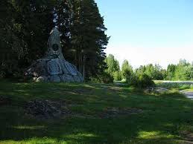](https://www.google.nl/url?sa=i&rct=j&q=&esrc=s&source=images&cd=&ved=0ahUKEwjY-6WnitjPAhVCXBoKHbilAkwQjRwIBw&url=http%3A%2F%2Fwww.wikiwand.com%2Fsv%2FSlaget_vid_Jutas&psig=AFQjCNFp79ND4a62PzCWJPiZqPYJPLw4Qg&ust=1476458403577688&cad=rjt)

Monument Slag van Jutas