Apsley House
From Wikipedia, the free encyclopedia
Apsley House
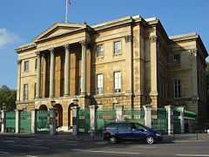
Apsley House, as it is today, Hyde Park Corner, London.
General information
Architectural style | neo-classical
Town or city | City of Westminster, London, England, United Kingdom
Country | United Kingdom
Coordinates | 51°30′12″N 0°09′05″W51.5032°N 0.151491°W
Construction started | 1771
Client | Henry Bathurst, Lord Apsley; Arthur Wellesley, 1st Duke of Wellington
Design and construction
Architect | Robert Adam  Benjamin Dean Wyatt (extensive renovations)
Listed Building – Grade I
Reference No. | 1226873^{[1]}
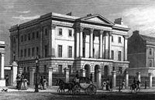
Apsley House in 1829 by TH Shepherd. The main gateway to Hyde Park can be glimpsed on the left.
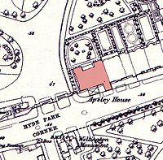
Apsley House on an 1869 map. The neighbouring houses were demolished in the post World War II period to allow Park Lane to be widened. The Wellington Arch has been moved since this time.
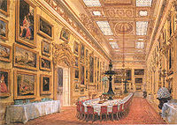
The Waterloo Gallery at Apsley House by Joseph Nash, 1852.
Apsley House, also known as Number One, London, is the London townhouse of the Dukes of Wellington. It stands alone at Hyde Park Corner, on the south-east corner of Hyde Park, facing south towards the busy traffic roundabout in the centre of which stands the Wellington Arch. It is a Grade I listed building.
The house is now run by English Heritage and is open to the public as a museum and art gallery, although the 8th Duke of Wellington still uses the building as a part-time residence. It is sometimes referred to as the Wellington Museum. It is perhaps the only preserved example of an English aristocratic town house from its period. The practice has been to maintain the rooms as far as possible in the original style and decor. It contains the 1st Duke's collection of paintings, porcelain, the silver centrepiece made for the Duke in Portugal, c. 1815, sculpture and furniture. Antonio Canova's heroic marble nude of Napoleon as Mars the Peacemaker made 1802-10, holding a gilded Nike in the palm of his right hand, and standing 3.45 metres to the raised left hand holding a staff. It was set up for a time in the Louvre and was bought by the Government for Wellington in 1816 (according to Nikolaus Pevsner) and stands in Adam's Stairwell.

History
Apsley House stands at the site of an old lodge that belonged to the crown. During the Interregnum newer buildings were erected between what is now Old Regent Street and Hyde Park Corner. In the 1600s after the Restoration they were leased by James Hamilton (died 1673) and renewed by Elizabeth his widow in 1692 on a 99 year lease (Hamilton Place takes its name from that family). Immediately before Apsley House was built the site was occupied by a tavern called the Hercules Pillars (immortalised by Henry Fielding in The History of Tom Jones, a Foundling as the location where Squire Western resides when he first journeys up to London).^{[2]}
The house was originally built in red brick by Robert Adam between 1771 and 1778 for Lord Apsley, the Lord Chancellor, who gave the house its name. Some Adam interiors survive: the semi-circular Staircase, the Drawing Room with its apsidal end, and the Portico Room, behind the giant Corinthian portico added by Wellington.
The house was given the popular nickname of Number One, London, since it was the first house passed by visitors who travelled from the countryside after the toll gates at Knightsbridge.^{[3]} It was originally part of a contiguous line of great houses on Piccadilly, demolished to widen Park Lane: its official address remains 149 Piccadilly, W1J 7NT.^{[4]} In 1807 the house was purchased by Richard Wellesley, 1st Marquess Wellesley, the elder brother of Sir Arthur Wellesley, but in 1817 financial difficulties forced him to sell it to his famous brother, by then the Duke of Wellington, who needed a London base from which to pursue his new career in politics.
Wellington employed the architect Benjamin Dean Wyatt to carry out renovations in two phases: in the first, begun in 1819, he added a three-storey extension to the north east, housing a State Dining Room, bedrooms and dressing rooms.^{[5]} The second phase, started after Wellington had become Prime Minister in 1828, included a new staircase and the "Waterloo Gallery" on the west side of the house.^{[5]} The red-brick exterior was clad in Bath stone, and a pedimented portico added.^{[6]} Wyatt's original estimate for the work was £23,000, but the need to repair structural defects discovered during the work led to costs escalating to more than £61,000.^{[5]} Wyatt introduced his own version of French style to the interior, notably in the Waterloo Gallery and the florid wrought iron stair-rail, described by Pevsner as "just turning from Empire to a neo-Rococo" .
The Waterloo Gallery is, of course, named after the Duke's famous victory over Napoleon at the Battle of Waterloo. A special banquet is still served annually to celebrate the date — 18 June 1815. The Duke's equestrian statue can be seen across the busy road, cloaked and watchful, the plinth guarded at each corner by an infantryman. This statue was cast from guns captured at the battle.
Gerald Wellesley, 7th Duke of Wellington, gave the house and its most important contents to the nation in 1947, but by the Wellington Museum Act 1947 the right of the family to occupy just over half the house was preserved "so long as there is a Duke of Wellington".^{[7]} The family apartments are now on the north side of the house, concentrated on the second floor.

Paintings collection
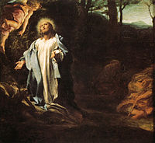

The Agony in the Garden, Antonio da Correggio, c. 1524
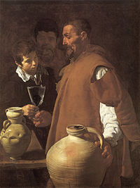

The Waterseller of Seville, Diego Velázquez, 1618-1622
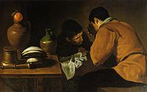

Two men sitting at the table, Diego Velázquez, c. 1618
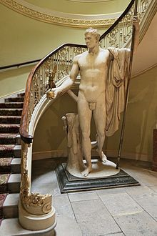
Apsley House London, Napoleon as Mars the Peacemaker statue by the Italian artist Antonio Canova of Napoleon I of France
The notable collection of 200 paintings includes 83 which were acquired by the first Duke after the Battle of Vitoria in 1813. The paintings were in Joseph Bonaparte's baggage train; they were from the Spanish royal collection and were presented to Wellington by King Ferdinand VII of Spain. The painting collection includes work by:^{[8]}
American School
- John Singleton Copley
British School
- Sir William Beechey
- John Burnet
- George Dawe
- John Hoppner
- Edwin Landseer
- Sir Thomas Lawrence
- William Salter
- Sir David Wilkie
Dutch School
- Pieter de Hooch
- Jan van Huysum
- Nicolaes Maes
- Willem van Mieris
- Antonis Mor
- Aernout van der Neer
- Adriaen van Ostade
- Cornelius van Poelenburgh
- Jan Steen
- Willem van de Velde the Younger
- Jan Victors
Flemish School
- Paul Brill
- Adriaen Brouwer
- Jan Brueghel the Elder
- Anthony van Dyck
- Antony Francis van der Meulen
- Rubens
- David Teniers the Younger
French School
- Claude Lorrain
- Claude-Joseph Vernet
German School
- Hans von Aachen
- Adam Elsheimer
- Anton Raphael Mengs
Italian School
- Leandro Bassano
- Giuseppe Cesari
- Carlo Cignani
- Antonio da Correggio
- Luca Giordano
- Antiveduto Grammatica
- Guercino
- Giovanni Paolo Panini
- Guido Reni
- Giulio Romano
- Salvator Rosa
- Francesco Trevisani
- Marcello Venusti
Spanish School
- Velázquez, Diego (4 paintings, including The Waterseller of Seville)
- Francisco Goya (1 painting)
- Bartolomé Esteban Murillo (3 paintings)
- Jusepe de Ribera (3 paintings)
The 1st Duke received many gifts from European continental rulers that are displayed in the House:
- A pair of large candelabra of Siberian porphyry, ormolu & Malachite centre and two side tables, presented by Nicholas I of Russia.
- A pair of Swedish porphyry urns, from King Charles XIV John of Sweden.
- A dinner service of Berlin porcelain, from Frederick William III of Prussia.
- The Egyptian revival decorative arts dinner service of Sèvres porcelain, from Louis XVIII of France.
- The silver and silver-gilt Portuguese service of over a thousand pieces, from the Portuguese Council of Regency.
- The Saxon Service of Meissen porcelain, from Frederick Augustus I of Saxony.
- Seven marshal's batons from various European continental rulers (and another three from the British). Nine of them are on display at Aspley House (the Russian baton was stolen in the 1960s).
The Duke's uniform and other memorabilia may be seen in the basement.

