Public Member Photos & Scanned Documents  Pictures  
  Photo: | Location for Bowes Foord Plaque St. Pauls
  Category: | Other
  Description: | The Bowes Foord Plaque North Transcept west wall St Pauls Cathederal London England.
  Attached To: | Barnard Foord-Bowes (1769-1812)
 | Public Member Photos & Scanned Documents  Pictures  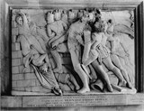
  Photo: | General Barnard Foord St Pauls
  Category: | Other
  Description: | Memorial Plaque to Brigadier General Barnard Foord Bowes.
  Attached To: | Barnard Foord-Bowes (1769-1812)
 | Public Member Photos & Scanned Documents  Pictures  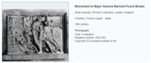
  Photo: | Major General Bernard Foord Bowes died 1812
  Category: | Portrait
  Attached To: | Major General Bernard Foord Bowes (1769-1812)

