Family Scrapbooks > Westcott > Graves and memorials > Capt. George Blagdon Westcott > London
Captain George B. Westcott (1753-1798)
Memorial, St. Paul's Cathedral, London
ERECTED AT THE PUBLIC EXPENSE  TO THE MEMORY OF  GEORGE BLAGDON WESTCOTT,  CAPTAIN OF THE MAJESTIC;  WHO, AFTER THIRTY THREE YEARS OF MERITORIOUS SERVICE,  FELL GLORIOUSLY  IN THE VICTORY OBTAINED OVER THE FRENCH FLEET OFF ABOUKIR,  THE FIRST DAY OF AUGUST IN THE YEAR MDCCXCVIII,  IN THE FORTY SIXTH YEAR OF HIS AGE. | 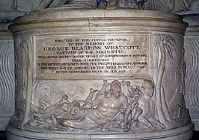
In St. Paul's Cathedral, a memorial was erected to commemorate the hero of the Battle of the Nile who died in action against Napoleon's French fleet. Whereas Lord Nelson's body was brought back to Britain for a state funeral, after his death at Trafalgar in 1805, Captain Westcott's remains were immediately buried at sea. The memorial stands on the right-hand side of the nave, in the form of a round plinth, surmounted by statues of an angel and a dying warrior in Roman dress. There is an allegorical frieze on the plinth, and on the wall behind. The legend is the same as the memorial in Honiton.

