Tribute to Henry Mackinnon
For all discussions relating to the Peninsular War of 1808-14.
Post a reply
Bovenkant formulier
Onderkant formulier
5 posts • Page 1 of 1

Tribute to Henry Mackinnon
by berto » May 10th, 2012, 1:09 pm
Major-General Henry MacKinnon (August, 1773 – January 19, 1812) commanded the 45th, 74th, and 88th regiments during the Peninsular War. He was killed while leading Picton’s third army during the attack on The Great Breach at Ciudad Rodrigo on 19 January 19 1812. Mackinnon’s body was recovered and buried by his regiment in the village of Espeja, where the Coldstream Guards were encamped.
A bicentennial plaque was unveiled on 23 January 2012 in Espeja in honour of Maj Gen MacKinnon.
Mackinnon’s memoires, A journal of the Campaign in Portugal and Spain 1809-1812, were published posthumously for the benefit of his young sons. Miguel Angel Martin Mas’ Spanish translation is not for sale but freely available at the Espeja town hall [ajuntamiento].
Prior to the Napoleonic wars, when his father resided in the French province of Dauphiny where Napoleon was a frequent visitor, MacKinnon had a cordial acquaintance with his future enemy.
See also http://miguelangelmartinmas.blogspot.pt ... ueblo.html
Thanks Sarah for translating all
Greetings!
Attachments
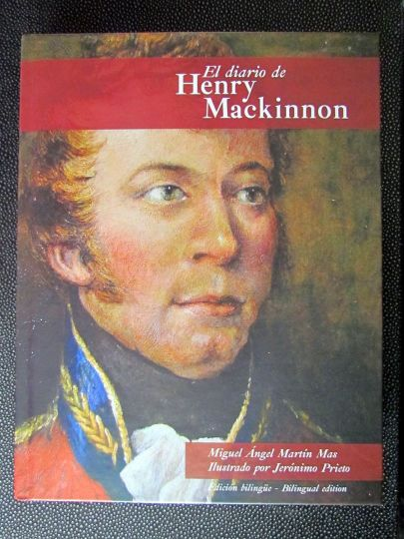
resized_resized_resized_Espeja 002.jpg (50.19 KiB) Viewed 1085 times
