Wallace Collection
From Wikipedia, the free encyclopedia
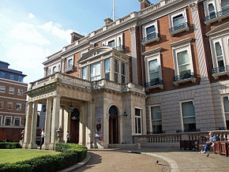
Hertford House in Manchester Square, London, home of the Wallace Collection
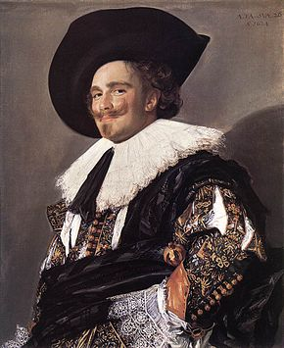
Frans Hals – The Laughing Cavalier, 1624
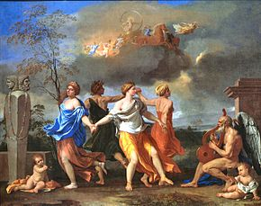
Nicolas Poussin – A Dance to the Music of Time, c. 1634–36
The Wallace Collection is an art collection in London open to the public, housed at Hertford House in Manchester Square, London, the former townhouse of the Seymour family, Marquesses of Hertford. It comprises a world-famous range of fine and decorative arts from the 15th to the 19th centuries with large holdings of French 18th-century paintings, furniture, arms & armour, porcelain and Old Master paintings arranged into 25 galleries.
It was established in 1897 from the private collection mainly created by Richard Seymour-Conway, 4th Marquess of Hertford (1800–1870), who left both it and the house to his illegitimate son Sir Richard Wallace (1818–1890), whose widow bequeathed the entire collection to the nation. The collection opened to permanent public view in 1900 in Hertford House, Manchester Square, and remains there to this day. A condition of the bequest was that no object should ever leave the collection, even for loan exhibitions. Admission is free.
The Wallace Collection is a non-departmental public body.

Collections
The Collection numbers nearly 5,500 objects and is best known for its quality and breadth of eighteenth-century French paintings, Sèvres porcelain and French furniture.
The Wallace Collection also displays many other treasures, such as two paintings by Titian, five Rembrandts, nine Rubenses, four Van Dycks, eight Canalettos, nineteen Bouchers, masterpieces by de Hooch, nine Teniers, Frans Hals, nine Murillos, two Velázquez and paintings by Domenichino, Cima, Daddi, Reni, Rosa, Thomas Gainsborough, Joshua Reynolds, Antoine Watteau, Nicholas Lancret, Jan Steen, Aelbert Cuyp and nine Guardis. The Collection also includes a fine collection of arms and armour, featuring both European and Oriental objects, as well as displays of gold boxes, miniatures, sculpture and medieval and Renaissance works of art such as maiolica, glass, bronzes and Limoges enamels.
The works of art in the Collection comprise:^{[1]}
- Paintings, watercolours and drawings 775
- Furniture 528
- Ceramics 510
- European and Oriental arms and armour 2,370
- Sculpture 466
- Miniatures 334
- Medieval and Renaissance works of art 363
- Goldsmiths' work 120
- 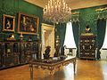
Large Drawing Room - Contains some of the most spectacular works by the French furniture-maker, Andre-Charles Boulle
- 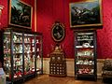
Part of the Wallace Collection's great ensemblage of Sèvres porcelain
- 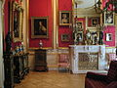
Front State Room - Redecorated in the mid-1990s to appear as though it would have in the late-19th century
- 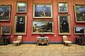
The Great Gallery in 2012, featuring Rubens' "Landscape With A Rainbow", portraits by Van Dyck, and other important works

Building
The 16th and 17th century Hertford House, townhouse of Edward Seymour, 1st Earl of Hertford (1539-1621) was in a different location, namely in Cannon Row in Westminster. His father Edward Seymour, 1st Duke of Somerset (executed 1552), brother of Queen Jane Seymour, had started building the palatial Somerset House on the Strand as his townhouse, but did not live to complete it. The present House in Manchester Square was the townhouse of a later branch of the family. In 2000 the inner courtyard was given a glass roof and a restaurant was opened named "Cafe Bagatelle" after the Château de Bagatelle in Paris purchased in 1835 by Francis Seymour-Conway, 3rd Marquess of Hertford. The Wallace Restaurant is now run by Peyton and Byrne as a French-style brasserie. The architect was Rick Mather.^{[2]}

Departments
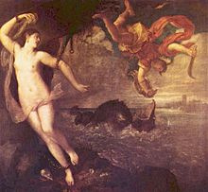
Titian – Perseus and Andromeda, c. 1554–56
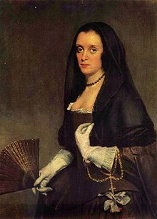
Diego Velázquez – Lady with a Fan
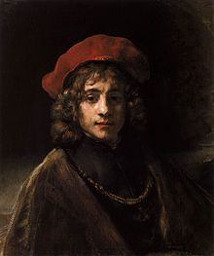
Rembrandt – The Artist's Son Titus, c. 1657
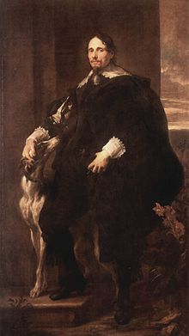
Anthony van Dyck – Porträt des Philippe Le Roy, 1630
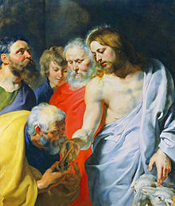
Peter Paul Rubens – Christ's Charge to Peter, c. 1616
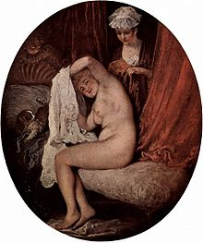
Antoine Watteau – A Lady at her Toilet, c. 1716–18)
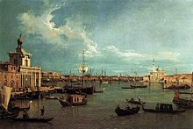
Canaletto (Giovanni Antonio Canal) – The Bacino from the Giudecca, Venice, c. 1740
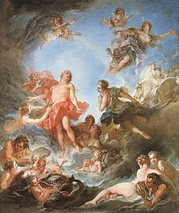
François Boucher – The Rising of the Sun, 1753
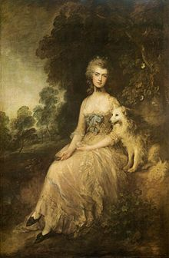
Thomas Gainsborough – Mrs Mary Robinson (Perdita), c. 1781
The Wallace Collection is split into six curatorial departments, Pictures and Miniatures, Ceramics and Glass, Sculpture and Works of Art, Arms and Armour, Sèvres porcelain and Gold Boxes and Furniture.

Pictures and miniatures
The Wallace Collection's Old Master paintings represent some of the finest works of art in the world, executed by most of the leading artists of their period. The paintings include important works from all periods between the fourteenth to the mid-nineteenth century.
The Wallace Collection is particularly strong in Dutch and Flemish paintings of the seventeenth century and in eighteenth and nineteenth-century French paintings, though there are also outstanding works by English, Italian and Spanish artists. Strengths of the collection include examples by Rembrandt, Rubens, Van Dyck, Canaletto, Gainsborough, François Boucher, Fragonard, Murillo, Titian, Poussin and Velázquez.
The inventory of pictures, watercolours and drawings comprises all the major European schools.

Paintings, drawing and watercolours from the Wallace Collection[edit]
- British, German, Spanish & Italian – 151 paintings, 60 drawings^{[3]}
- French (19th Century) – 134 paintings, 57 watercolours^{[4]}
- French (before 1815) – 144 paintings, 8 drawings and watercolours^{[5]}
- Dutch – 173 paintings, 2 drawings^{[6]}
- Flemish – 8 paintings^{[6]}
Dutch School
- Gerard ter Borch – 2 paintings;
- Aelbert Cuyp – 6 paintings;
- Gerrit Dou – 1 painting;
- Frans Hals – 1 painting;
- Meyndert Hobbema – 5 paintings;
- Pieter de Hooch – 2 paintings: A Boy Bringing Bread and A Woman Peeling Apples;
- Gabriel Metsu – 5 paintings;
- Adriaen van Ostade – 2 paintings;
- Rembrandt – 6 paintings;
- Jacob Isaakszoon van Ruisdael – 5 painting;
- Frans Snyders – 1 painting;
- Jan Steen – 5 paintings;
- Adriaen van de Velde – 2 paintings;
- Willem van de Velde the Younger – 8 paintings;
- Jan Weenix – 13 paintings;
- Philip Wouwerman – 6 paintings;
English School
- Thomas Gainsborough – 2 paintings;
- John Hoppner – 1 painting;
- Sir Edwin Landseer – 4 paintings;
- Thomas Lawrence – 4 paintings;
- Joshua Reynolds – 12 paintings;
- J.M.W. Turner – 4 paintings;
Flemish School
- Marcus Gheeraerts the Younger – 1 painting;
- Jan Mabuse – 1 painting;
- Hans Memling – 1 painting;
- Pieter Pourbus – 1 painting;
- Peter Paul Rubens – 9 paintings;
- David Teniers the Younger – 2 paintings;
- Anthony van Dyck – 4 paintings ;
French School
- François Boucher – 20 paintings;
- Philippe de Champaigne – 4 paintings;
- François Clouet – 2 paintings;
- Jean-Baptiste-Camille Corot – 1 painting;
- Eugène Delacroix – 2 paintings;
- Hippolyte Delaroche – 12 paintings;
- Gaspard Dughet – 1 painting;
- Jean-Honoré Fragonard – 8 painting;
- Claude Lorrain – 1 painting;
- Théodore Géricault – 1 painting;
- Jean-Baptiste Greuze – 19 paintings;
- Jean-Marc Nattier – 3 paintings;
- Nicolas Poussin – 1 painting;
- Théodore Rousseau – 1 painting;
- Jean-François de Troy – 2 paintings;
- Claude-Joseph Vernet – 2 paintings;
- Horace Vernet – 24 paintings;
- Jean-Antoine Watteau – 9 paintings;
Italian School
- Canaletto, (Giovanni Antonio Canal) – 19 paintings;
- Giovanni Battista Cima da Conegliano – 2 paintings;
- Carlo Crivelli – 1 painting;
- Francesco Guardi – 9 paintings;
- Salvator Rosa – 1 painting;
- Andrea del Sarto – 1 painting;
- Titian (Tiziano Vecelli) – 1 painting;
- (Domenichino) – 1 painting;
Spanish School
- Bartolomé Esteban Murillo – 8 paintings;
- Diego Velázquez – 2 paintings;

Gallery

Paintings
Dutch paintings
- 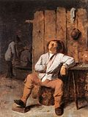
Adriaen Brouwer - Sleeping peasant
- 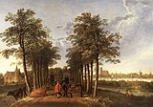
Aelbert Cuyp - The Avenue at Meerdervoort, 1650-52
Flemish paintings
- 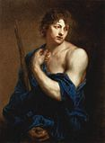
Anthony van Dyck - Paris, c. 1628
- 
Peter Paul Rubens - Landscape with a Rainbow, c. 1638
French paintings
- 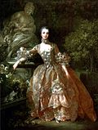
François Boucher - Madame de Pompadour, 1759
- 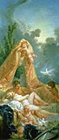
François Boucher - Mars and Venus
- 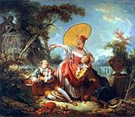
Jean-Honoré Fragonard - The Musical Contest, 1754-55
- 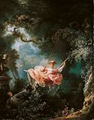
Jean-Honoré Fragonard - The Swing, 1767
- 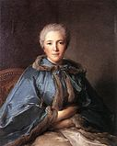
Jean-Marc Nattier - The Comtesse de Tillières, 1750
- 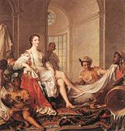
Jean-Marc Nattier - Mademoiselle de Clermont as a Sultana, 1733
- 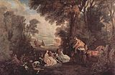
Jean-Antoine Watteau - The Halt during the Chase, c. 1718-20
Italian paintings
- 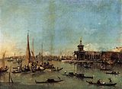
Francesco Guardi - The Dogana with the Giudecca, c. 1775
Spanish paintings
- 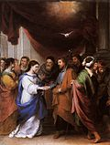
Bartolomé Esteban Murillo - Marriage of the Virgin, 1670

Ceramics[edit]
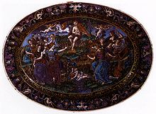

Renaissance Limoges enamel dish by Martial Courtois
There are fine examples of porcelain by the greatest of makers, including Meissen and one of the world's greatest collections of Sèvres.
The Wallace Collection contains the richest and most distinguished museum collections of eighteenth-century Sèvres porcelain in the world. It includes 137 vases, 80 tea wares, 67 useful wares, 3 biscuit figures and 130 plaques (mostly on furniture), and was acquired by the Marquesses of Hertford and Sir Richard Wallace between c. 1802–75.^{[7]}

Furniture
The Wallace Collection holds one of the most important collections of French furniture in the UK, and ranks alongside the Musée du Louvre, the Royal Collection, Waddesdon Manor, the collections of the Duke of Buccleuch, the Getty Museum and the Metropolitan Museum of Art as one of the greatest and most celebrated in the world.^{[8]} Totalling more than five hundred pieces, the collection consists largely of eighteenth-century French furniture but also includes some significant pieces of nineteenth-century French furniture, as well as interesting Italian furniture and a few English and German pieces. The collection ranges from cabinet furniture, much of which is veneered with brass and turtleshell marquetry (commonly known as "Boulle" marquetry) or with wood marquetry, to seat furniture, clocks and barometers, gilt-bronze items including mounted porcelain and hardstones, mantelpieces, mirrors, boxes and pedestals. One highlight of the collection is the major collection of furniture attributed to André-Charles Boulle (1642–1732), perhaps the best-known cabinet-maker ever to have lived.
Joseph Baumhauer – 1 item;
- Bas d'armoire, c. 1765–1770;
André-Charles Boulle – 22 items;
- Armoire, c. 1695;
- Armoire, c. 1700;
- Armoire, c. 1700;
- Armoire, c. 1715;
- Bureau plat, c. 1700–10;
- Cabinet avec son pied, c. 1667;
- Cartonnier et pendule, c.1715;
- Commode, c. 1710;
- Paire de grande table, c. 1705;
- Mantle clock, c. 1715;
- Mantle clock, c. 1726;
- Médaillier, c. 1710–20;
- Miroir de toilette, c. 1713, (delivered to the Duchesse de Berry);
- Paire de coffre de toilette, c. 1700;
- Paire de torchéres, c. 1700–10;
- Pendule et gaine, c. 1712–20;
- Pendule et gaine, c. 1720–25;
- Table à mettre dans un trumeau, c. 1705;
Martin Carlin – 4 items;
- Paire de Encoignures, c. 1772;
- Secrétaire à abattant, c. 1775;
- Table en secrétaire, c. 1783;
Adrien Delorme – 2 items;
- Paire de bibliothèque basse
Étienne Doirat – 1 item;
- Commode, c. 1720;
Étienne Levasseur – 5 items;
- Grande Bibliothèque, c. 1775;
- Paire de bibliothèque basse, c. 1775
- Paire de meubles à hauteur de'appui, c. 1775
Alexandre-Jean Oppenord – 3 items;
- Bureau plat, 1710;
- Commode, c. 1695;
- Écritoire, c. 1710;
Jean Henri Riesener – 10 items;
- Commode, delivered to Marie-Antoinette's cabinet intérieur de la reine at Versailles, c. 1780;
- Commode, delivered to Marie-Antoinette for Chateau de Marly, c. 1782;
- Encoignure, delivered to Marie-Antoinette's cabinet intérieur at Versailles, c. 1783;
- Secrétaire à abattant, delivered to Marie-Antoinette's cabinet intérieur at Versailles, c. 1783;
- Secrétaire à abattant, delivered to Marie-Antoinette's Petit Triannon at Versailles, c. 1783;
- Secrétaire à abattant, delivered to Marie-Antoinette's cabinet intérieur at Versailles, c. 1780;
- Bureau à cylindre, delivered to the comte d'Orsay for the Hôtel d'Orsay, c. 1774;
- Bureau à cylindre, c. 1785;
- Secrétaire à abattant, c. 1780-4;
- Table de toilette, c. 1780-4;
Bernard I Van Risen Burgh – 1 item;
- Bureau plat, c. 1719
Nicolas Sageot – 2 items;
- Commode, c.1700;
- Commode, c.1710;
Adam Weisweiler – 4 items;
- Paire de meubles à hauteur de'appui, c. 1780
- Paire de meubles à hauteur de'appui, c. 1785–90

References
- Jump up ^ The Wallace Collection Annual Report and Accounts 2004–05 HC 832
- Jump up ^ "The Wallace Collection: Cafe Bagatelle". Design Week. 24 August 2000. Retrieved 16 July 2012.
- Jump up ^ The Wallace Collection: Catalogue of Pictures I
- Jump up ^ The Wallace Collection: Catalogue of Pictures II
- Jump up ^ The Wallace Collection: Catalogue of Pictures III
- ^ Jump up to: ª ^{b} The Wallace Collection: Catalogue of Pictures IV
- Jump up ^ The Wallace Collection: Catalogue of Sèvres Porcelain – ISBN 0-900785-27-6
- Jump up ^ The Burlington Magazine, Vol. 139, No. 1136 (Nov., 1997), pp. 792–794
- Jump up ^ Walking directions to Wallace Collection from Bond Street tube station
- Jump up ^ Walking directions to Wallace Collection from Bond Street tube station

