William James Myer
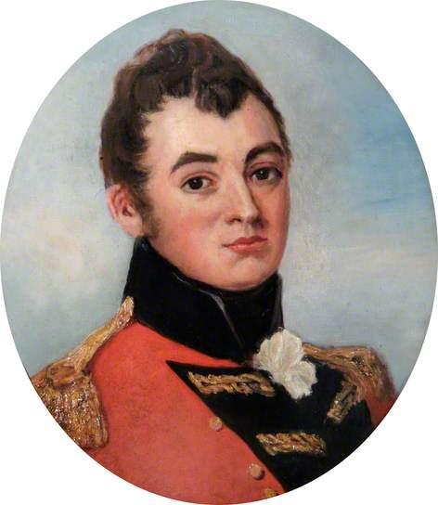
photo credit: The Fusilier Museum London More about image copyright

