- Photos  - Map  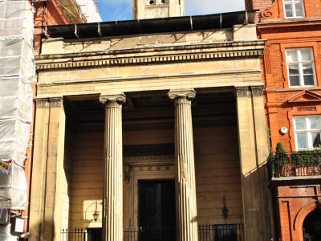  St Mark's Church  October 2011  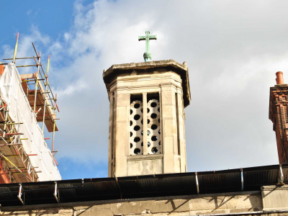  October 2011    October 2011 | St Mark's Church  Description of St Mark's Church  St Mark's Church is a Grade I listed building within the Mayfair Conservation Area.  The building, originally built in 1824, was officially declared redundant in 1974 and remained empty for a period of 20 years. The Commonwealth Church have occupied the church since 1994 however, the condition of the building has deteriorated in recent years suffering from water ingress and dry rot. The London Diocese have advised that the Commonwealth Church have been unable to pay for the expensive and extensive repairs that are required. Given the outstanding historical and architectural importance of this Grade I listed building English Heritage have designated it as a priority on their Buildings at Risk Register. The building has now  been on the register since 15 December 1988.  Source: westminster.gov.uk 2011
  Address: | St Mark's Church, North Audley Street, London W1K 6DP
  Type: | Public
  Completion: | 19th century
  Size:
  Viewed: | 705 times

