James McGrigor
From Wikipedia, the free encyclopedia
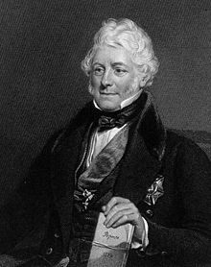
James McGrigor c. 1839
Sir James McGrigor, 1st Baronet FRSE FRS FRCPE MWS (9 April 1771 – 2 April 1858) was a Scottish physician, military surgeon and botanist, considered to be the man largely responsible for the creation of the Royal Army Medical Corps. He served as Rector of the University of Aberdeen.

Early life
The son of a clothing merchant, he was born in Cromdale, Inverness-shire, and educated at Aberdeen Grammar School and the University of Aberdeen. He received medical training at the University of Edinburgh.

Army surgeon
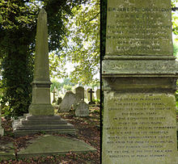

McGrigor's funerary monument at Kensal Green Cemetery, London, photographed in 2014
He joined the army as a surgeon in 1793 and saw service with an Irish regiment, the 88th Regiment of Foot, in Flanders, the West Indies and India. In 1811, he was appointed Surgeon-General for the Duke of Wellington's army in Spain and Portugal during the Peninsular Wars (1808–14).
McGrigor returned to Britain before the Battle of Waterloo, and was knighted (1814). He went on to serve as Director-General of the Army Medical Service (1815–51) and did much to reform that department. He introduced the stethoscope in 1821, set up field hospitals for those injured in action, and generally improved the standards of cleanliness and hygiene. His autobiography was published in 1861. An obelisk to his memory has been placed in Aberdeen and is now in Duthie Park.^{[1]} A statue was erected in Westminster, and later moved to the Royal Military Academy Sandhurst.

References
  - Jump up ^ "Entry". Gazetteer for Scotland. Retrieved 6 December 2010.

Further reading
- Blanco, Richard L. Wellington's Surgeon General; Sir James McGrigor. Durham, N.C., Duke University Press, 1974, 8vo., pp. xiv.
- McGrigor, Sir James (ed. Mary McGrigor). The Scalpel and the Sword: Sir James McGrigor: The Autobiography of the Father of Army Medicine edited by Mary McGrigor. Dalkeith Scottish Cultural Press, 2000. See review by Martin Howard

External links
- Sir James McGrigor, 1st Baronet
- Leigh Rayment' s baronetage page

