Warrior of Waterloo: Colonel John Cameron of Fassiefern
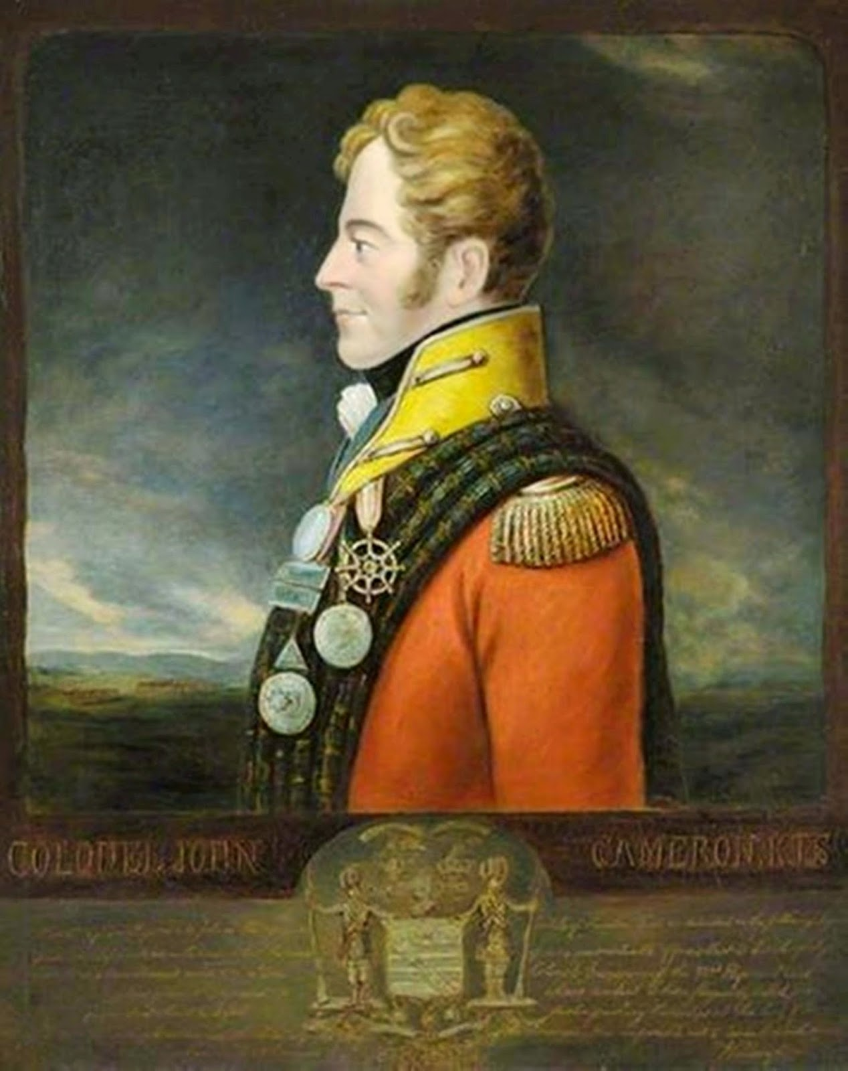
One of the greatest military men to hail from Lochaber was undoubtedly John Cameron of Fassiefern, named after a place situated beside the picturesque Lochiel. Lieutenant Colonel John Cameron was born in 1771, the grandson of John Cameron of Fassiefern who in 1745 had tried in vain to persuade his brother, the chief of Clan Cameron and known as “the Gentle Lochiel”, not to support Prince Charles Edward Stuart and the Jacobite Rising.
In 1794, when the Marquis of Huntly raised the 100th (later 92nd) Regiment, or Gordon Highlanders, young John Cameron was granted a Captain’s commission and raised a company from the Gordon estates in Lochaber. By 1815 he was the Lieutenant Colonel commanding the 92nd. He was mortally wounded at Quatre Bras on the first day of the three day Waterloo campaign. His memorial can be seen beside the present church and near to the old cemetery at Kilmallie, Corpach, Fort William.
The following historical story was transcribed by Calum Maclean on the 25th of January 1951 from a recording made by John MacDonald of Highbridge, Brae Lochaber:

Chaidh Iain an Fhasaidh Fheàrna a mharbhadh aig Waterloo. Agus ’s e fear de na compaich aige fhèin a rinn e. Bha e glè throm air na saighdeirean. Agus chaidh am peilear ann o thaobh a chùil. Agus thuirt fear a bha sa chuideachda:
“Chan e mo nàmhaid a rinn siud,” thuirt e ris.
"Creid," thuirt e, "nach e do charaide a bhuail o thaobh do chùil thu.”
Agus dh’aithnich am pìobaire aige. Bha e a’ cluich a’ phuirt agus dh’aithnich e an gnothach pìos air falbh agus thòisich e air cluich a’ phuirt. Bha compach a bh’ aig Iain pìos air falbh:
“Tha naidheachd mhòr ri innseadh an-diugh. Tha an t-eagal orm gum bheil Camshronach an Fhasaidh Fheàrna air a mharbhadh.”
Agus mar a thuirt b’ fhìor.
Dar a thàinig e, bha an Camshronach air a mharbhadh. Agus bha Waterloo ann ann an ochd ceud deug agus a còig deug. Thàinig an corp aige dhachaigh a h-uile car. Agus tha e air a thìodhlacadh an Cille Mhàilidh agus tìodhlacadh mòr. Agus tha carraig-chuimhne an àirde air a shon an Cille Mhàilidh am beul na h-eaglais. Agus chaidh marbhrann a dhèanadh dhà agus chan eil aon fhacal agam den òran a chaidh a dhèanadh. Ach bha mhathan gul agus cràdh air gach taobh de Loch Iall, dar a thàinig an corp aige air adhart. ’S e sin loch a tha a' dol a sìos naoidh mìle bho ceann amar nan long bhon a’ chanal gus an ruig sibh ceann Loch IalI a’ dol a sìos. Tha i mu thrì mìle an taobh-sa de Loch Seile, an stad an sin. Agus shin agad mar a thachair do dh’Iain an Fhasaidh Fheàrna. Agus bhon a chaidh a mharbhadh, cò fhuair an dleasnas a b’ àirde a ghabhadh toirt dà ach athair. Agus theireadh iad Sir Iain ri athair an deaghaidh dha mhac a bhith air a mharbhadh. Is cò ghabh an command an uair sin ach fear Mitchell a bha an Achadh na Dàla, agus tha e air a thoìdhlacadh am Blàr Odhar. Agus bha e na Chommand aig na Gòrdanaich. Agus ’s e Fear an Fhasaidh Fheàrna an ceannard a bh’ orra, nuair a dh’fhàg iad an Gearasdan. Agus ’s ann an sin a chaidh an togail. Agus tha e air a ghràdha anns a' Ghearasdan gus an latha an-duigh Gordon Square air an àite san deach na Gòrdanaich a thogail, agus Cameron Square air an àite san do thog Ailean an Earrachd iad. Bha na Gòrdanaich, cha robh iad toileach falbh idir, na saighdeirean. Agus bha Lady Gordon – ’s ann mar sin a fhuair iad na Gòrdanaich – Lady Gordon, nighean òg, chuir i tasdan na beul. Agus a h-uile saighdear a bheireadh an tasdan à beul bha e a toirt pòg dhi. Sin na thuirt i. Agus ghabh i mulad agus bròn glè mhòr dar a chunnaic i na gillean gasda a dh’fhalbh is nach do thill iad. ’S ann an sin a thuig i an call a rinn i don dùthaich a’ chuid a b' fheàrr do na laoich a chur air falbh agus nach do thill iad air ais.

And the translation goes something like the following:

John [Cameron] of Fassiefern was killed at Waterloo. It was one of his own company that committed the act. He was extremely harsh on his soldiers. The bullet entered his back. And one of the men who accompanied him said:
“It’s not your enemy who did that,” he said to him.
“Believe you me,” he replied, “it wasn’t your friend that shot you in the back.”
And his piper then knew and he played a tune as he knew even from a distance and so he began playing a tune. John’s companion was a little distance away:
“There’s some awful news to relate today. I’m afraid to say that Cameron of Fassiefern had been murdered.”
And that turned out to be true.
When it came down to it, Cameron had been murdered. Waterloo was fought in 1815. His remains arrived back home. He was buried in Kilmallie Cemetery and there was a huge funeral. A memorial was raised to his memory in Kilmallie Cemetery in front of the church. An elegy was composed for him but I don’t know one word of that song. But there were weeping and wailing women on both sides of Lochiel as the funeral cortege progressed. That’s the loch that stretches nine miles from the Caledonian Canal’s basin until you reach Kinlocheil. It’s about three miles from this side of Lochshiel where there’s a stop. And that’s what happened to John [Cameron] of Fassiefern. And because of his murder, who was raised to the highest of rank but his father. And they called his father Sir John after his son had been murdered. And who but a man called Mitchell from Achandual was given command; and who was buried in Blarour Cemetery. And he was the commander of the Gordon Highlanders, Cameron of Fassiefern was their commander when they left Fort William. That’s where they [the regiment] was raised. And to this very day they call the place where they were raised in Fort William Gordon Square, and also Cameron Square where Allan Cameron of Erracht raised them. The Gordon Highlanders were unwilling to leave, the ordinary soldiers. And Lady Gordon – after whom they were called – was a young woman and she placed a shilling in her mouth. Each soldier got a shilling from her when he kissed her. That’s what she said. And she became very sorry indeed when she saw the young stalwarts that went away but never returned. That is when she understood the loss she had caused to the country when the choicest heroes were sent away never to return.

Rather than John Cameron of Fassiefern being a tyrant and punishing all his infantry men willy-nilly for any misdemeanour, it is perhaps more likely that he was assassinated by a disgruntled soldier that a short time previously he had instructed to be flogged. It should also be mentioned that in 1817 a baronetcy was conferred upon John Cameron’s father Ewen, in recognition of the distinguished military services of his late son. Sir Ewen died in 1828, at the age of ninety, and the baronetcy has since become extinct after the death of Sir Duncan Cameron, younger brother of Colonel Cameron, and second and last baronet of Fassiefern.

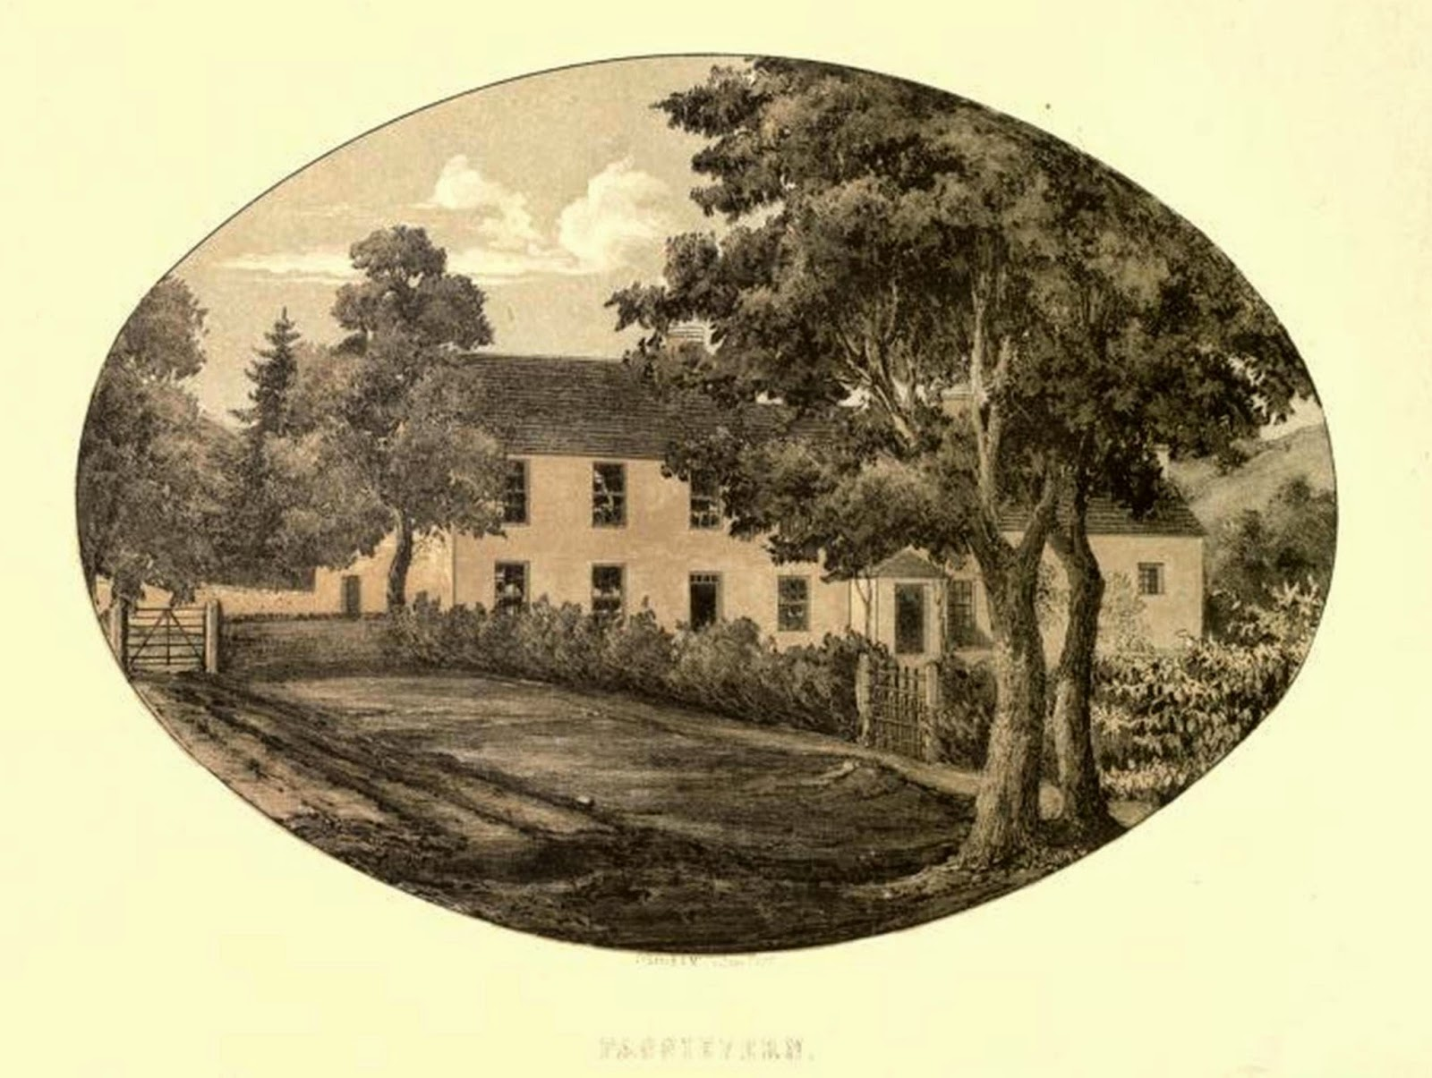

The story obviously struck a chord with Calum Maclean who decided to include it in his book The Highlands (1959):

At Corpach there is a very fine obelisk in memory of Col. John Cameron of Fassiefern who commanded the Gordons on the eve of Waterloo. He was killed at Quatre Bras on the eve of the battle. His body was brought home to Lochaber and his was the most magnificent funeral that Lochaber has ever seen. One hundred and thirty-nine years have passed since the eve of Waterloo. The monument raised in memory of Col. John Cameron stands to this day, but in Lochaber another tradition has long outlived the oldest veteran of the Napoleonic Wars. I doubt if any formal historian knows what Col. Cameron’s last words were, but most formal historians would not understand them in any case, for they were spoken in Gaelic. In Sweden a fierce controversy has raged for many years between formal historians and the brilliant director of the Marburg Museum on the west of Sweden. The point at issue is the nature of the death of Sweden’s heroic king, Charles XII. There has been a persistent tradition that Charles XII was shot by one of his own men. Dr Sandklef’s researches have gone a way towards proving that the tradition was based on actual fact. The formal historians have written lengthy volumes to disprove that thesis. Recently Dr Sandklef seems to have had the best of the argument. I do not wish to precipitate another controversy regarding a Scottish hero. In Lochaber it is still said that Col. John Cameron was not killed by a French bullet. He met his death at the hands of one of his own men. As he lay dying, he said to his Gaelic-speaking adjutant: “Chan e mo nàmhaid a rinn siud.” (It was not my foe that did that).
The adjutant replied: “Biodh fhios agad nach e do charaid a rinn e.” (Be assured that it was not your friend that did it).

Although making no mention of friendly-fire (indeed contradicting the above account), the Rev. Archibald Clerk (1813–1887), minister of Kilmallie, furnishes an interesting narrative of how Col. John Cameron of Fassiefern met his death in the heat of battle as follows:

We give the account of his fall as related to us by an eye-witness still living to confirm the narrative. The regiment lined a ditch in front of the Namur road. The Duke of Wellington happened to be stationed among them. Colonel Cameron, seeing the French advance, asked permission to charge them. The Duke replied, “Have patience, and you will have plenty of work by and by.” As they took possession of the farmhouse, Cameron again asked leave to charge, which was again refused. At length, as they began to push on to the Charleroi road, the Duke exclaimed, “Now, Cameron, is your time take care of that road.” He instantly gave the spur to his horse; the regiment cleared the ditch at a bound, charged, and rapidly drove back the French; but while doing so, their leader was mortally wounded. A shot fired from the upper storey of the farmhouse passed through his body, and his horse, pierced by several bullets, fell dead under him. His men raised a wild shout, rushed madly on the fated house, and, according to all accounts, inflicted dread vengeance on its doomed occupants.

Ewen Macmillan, who was over near his master and his friend, speedily gave such aid as he could. Carrying him, with the aid of another private, beyond reach of the firing, he procured a cart, whereon he laid him, carefully and tenderly propping his head on a breast than which none was more faithful. The life-blood, however, was ebbing fast, and on reaching the village of Waterloo, where so many other brave hearts were soon after to bleed, Macmillan carried Fassiefern into a deserted house by the road side, and stretched him on the floor. He anxiously inquired how the day had gone, and how his beloved Highlanders had acquitted themselves. Hearing that, as usual, they had been victorious, he said, “I die happy, and I trust my dear country will believe that I have served her faithfully.” His dying hour was soothed by that music which he always loved, and which, while harsh and unmeaning to a stranger, is so intimately blended with a Highlander’s deepest feelings, and most sacred memories, as to awaken his whole heart, to rouse up his whole being, and thus is highly esteemed in the hour of sorrow or of danger, in every great crisis of life. Better still, his dying hour was soothed, and we trust blessed, by earnest prayer. And worthy of remark it is that these dying supplications were littered in that mountain tongue, the first which he had heard in youth, and now, as we have known in kindred instances, at the close of life, naturally offering itself as the vehicle of the deepest aspirations of the soul in the most solemn of all situations.

Thus he met with a warrior’s death, and more, with a Highland warrior’s death. His remains were hastily interred in a green alley Allee verte on the Ghent road, under the terrific storm of the 17th, which, as has often been remarked, seemed to presage the “dread confusion, noise, and garments rolled in blood,” that render the 18th a day ever memorable in the annals of mankind. The funeral was attended, we need scarcely say, by the attached Macmillan, by Mr Gordon, already mentioned, and by a few soldiers, disabled by the wounds of Quatre Bras from standing aside their comrades in the fight, but still able and most willing to pay this last tribute of respect and affection to their lamented leader.

The lament referred to by John MacDonald, which he must have heard about but did not actually known any of the words, was composed by Glengarry’s bard, Allan MacDougall (1750–1829), known as Ailean Dall, a native of Glencoe. He was also a fiddler and a very able composer of Gaelic poetry. Cumha do Chorineal Iein Camshron, a thuit ann am blàr Bhatarlaidh, agus chaidh a chorp thoirt dhachaidh do Chill-a-Mhallaibh, ‘n Lochabar [A Lament for Colonel John Cameron who fell at the battle of Waterloo, and whose remains were returned home to Kilmallie, Lochaber] has all the hallmarks of a conventional elegy so apparent in Gaelic song tradition and is here reproduced in full with unamended spelling with a rather rough translation that follows:

AIR FONN:–“Gur muladach mi liom fhin,
’S gu’d duine mu ’n cuairt.”

’S LIONMHOR caraid a fear daimh,
Nach gearain a cheann bhi tinn,
Chaidh a leagadh ’s an Fhraing,
’S a chuir Bonaparte thall d’ar dith;
Ged bha Wellington ann,
’Chuir scapadh ’na champ bho thir,
’S leir ri fhaicinn ar call,
Dh’ fhag na Gaidheal cho gann ri ’r linn.

’N sgeul a thainig as ùr,
Dh’ fhag na h-Abraich fo thursa bron,
’S iad gun mhire, gun mhuirnn,
Gun aidhear, gun sunnt ri ceol;
Chaill iad caraid ’sa chùirt,
’S treun bharrantas cuil air sloigh;
’S lionmhor Morair a’s Diùchd,
A bha cràiteach mu ’n diubhal mhoir.

Chunnacas long anns a chaol,
’S i ’seoladh le gaoth’ bho ’n iar,
Dol gu Fasadh nan craobh,
’S ann leamsa nach b’ fhaoin an sgial;
’S corp àluinn an laoich
Air a clàr, ’s gun bu daor a thriall,
’S dh’ fhag sid bròn agus gaoir,
Aig mnathan dà thaobh Loch-iall.

Latha blàir Bhatarlaidh,
Thuit ’n t-shaoidh sin fhuair cliu ’s gach tir,
Mor Chamshronach ur,
Choisinn urram an cuirt an Righ;
Fhir nach tionndadh do chùl,
Nuair a reachadh a chuis gu stri,
’S tric a dhearbh thu do thuirnn,
’S a fhuair sinn' ort cunntas fìor.

D' fhuil ’ga dortadh air mhire,
Dh’ fhag cho doineach do chinneadh gu leir
A’s do chreuchdaibh a’ sìleadh,
’S cha robh doigh air a tilleadh le leigh,
’S gun a d’ choir ach do ghille,
’S e brònach le tiom’ as do dheigh;
’S cha bu leoin an cul slinnein,
Leis ’n do thuit thu ’san ìomairt, ’s b’e ’m beul.

Bu tù ’m buachaill’ air treud,
Gu’n gleidheadh bho bheud gun chall,
Gus an cuirte orra feum,
’S iad uil’ air dheadh ghleus a’ d’ champ;
Neartmhor, fulanach, treun,
Fad ’sa sheasadh tu fein air an ceann:
Bhiodh do naimhdean lan chreuchd,
’S tu cur an ra-treut’ na deann.

Sàr churaidh gun chealg,
Cait’ an cualas fear t-ainm ri d’ linn:
A dh’ fhuirich no dh’ fhalbh,
Thug ort urram le dearbhadh fìor;
Ann an cumadh, ’s an dealbh,
No ’n cumasg nan arm dol sios,
Leomhan fuileachdach, garg,
’S lan ghaisgeach gun chearb ’san stri.

Fer do choltais le cinnt’,
Cha ’n fhaicte 'n cuig mil' air sraid,
Gun chron cum’ ort ri inns',
Bho mhullach do chìnn, gu d’ shail;
’S d’ airm ghasd' air do shlinn,
Leis an reachadh tu ’n tionnsgladh blàir,
Ann an cogadh no ’n sith,
’S tu bhuidh’neadh a chis thair chach.

Bu ghlan ruathadh a d’ ghruaidh,
Air each aigionnach, luath, ’chinn aird,
’S tu air thoiseach do shluaigh,
Nuair a tharruineadh tu suas bragàd;
Claidheamh nochda’ gun truaill,
Leis an coisneadh tu buaidh a d’ laimh.
Lann thana, gheur, chruaidh,
Scathadh chlaignean, a’s cluas gu làr.

’s mairg a spionadh dhiot calg,
Nuair a lasadh do mheamna d’ shroin,
Lamh dheas air chul arm,
Leis an reachadh tu an sealbh a ghleois;
’Ghleidheadh onoir do ’n righ,
’S cha leigeadh tu dhiot a’ choir;
’S goirt do chairdean ’ga d’ dhith,
’S nach d’ fhan thu a dh innse sgeoil.

Sid an sgeula ’bha goirt,
Dh’ fhag Sir Eoghan na thosd, gun sunnt,
’S beag an t-ioghnadh a sprochd,
’S deoir bhi sileadh bho ’roisg’ gu dlu’,
A dheadh mhac oighre gun spot,
A dh’ fhoillsich le ’phosta cliù,
Dhol gu bàs le trom lot,
Air a chàramh a nochd ’s an ùir.

An latha mor sin chaidh crioch
Air a chogadh, ’s gach rioghachd thall,
'S iomadh laoch bu mhor pris,
A thuit leis an stri ’s an Fhraing,
Phaigh Cloinn Camshroin a chìs,
’S cha d’ thig iad air tir gun chall;
’S ged a thainig an t-shith,
’S daor a h-éiric ’s an diol a bh’ ann.

An la fhuair iad bho’n Fhraing
Do chorp prìseil a nall thar chuan,
’N ciste ghiubhais nam bord,
Ged ’bha ’n fhailt ud cho bronach, fuar;
Dh’ àrduich d’ onoir cho mor,
’S nach bu mhuillean do ’n òr a luach,
Do thoirt dachaidh le coir,
’S do thasgaidh fo ’n fhod far ’m bu dual.

‘N Cill-a-Mhaillibh nam feirt,
Chaidh an laoch bu mhor neart fo dhion,
’Na uir dhuchasaich cheart,
Ann an tùr na ’n clach snaighte, grinn;
Ge b’e ghabhas dùr-bheachd,
Air scriobhadh na ’n leachdan slinn,
’S leir an sid gur ceann feachd,
Fhuair urram le ceartas Righ.

Fad ’sa shiubhlas a ghrian,
Dol deiseal na nial gu h ard,
Gus an leagh le teas dian,
Na beanntuinnean sios gu lar;
Cluinnear iomradh do ghniomh,
Gus an teirig gach sliabh ’s gach traigh,
Seasaidh fianuis do bhuadh,
’S do chuimhneachan suas gu bràth.

’S ann an Lunnuinn nan cleochd,
Dhealbh iad ioghnadh ro mhor mu d’ chàs,
Ris ’n do chosdadh an t-òr,
Obair innealta, sheolt lamh;
’S nam b’i iomairt na ’n dornn,
A bheireadh tu beo bho ’n bhàs,
Cha leigeadh crùn Dheorsa
Thu laidhe fo ’n fhod cho trath.

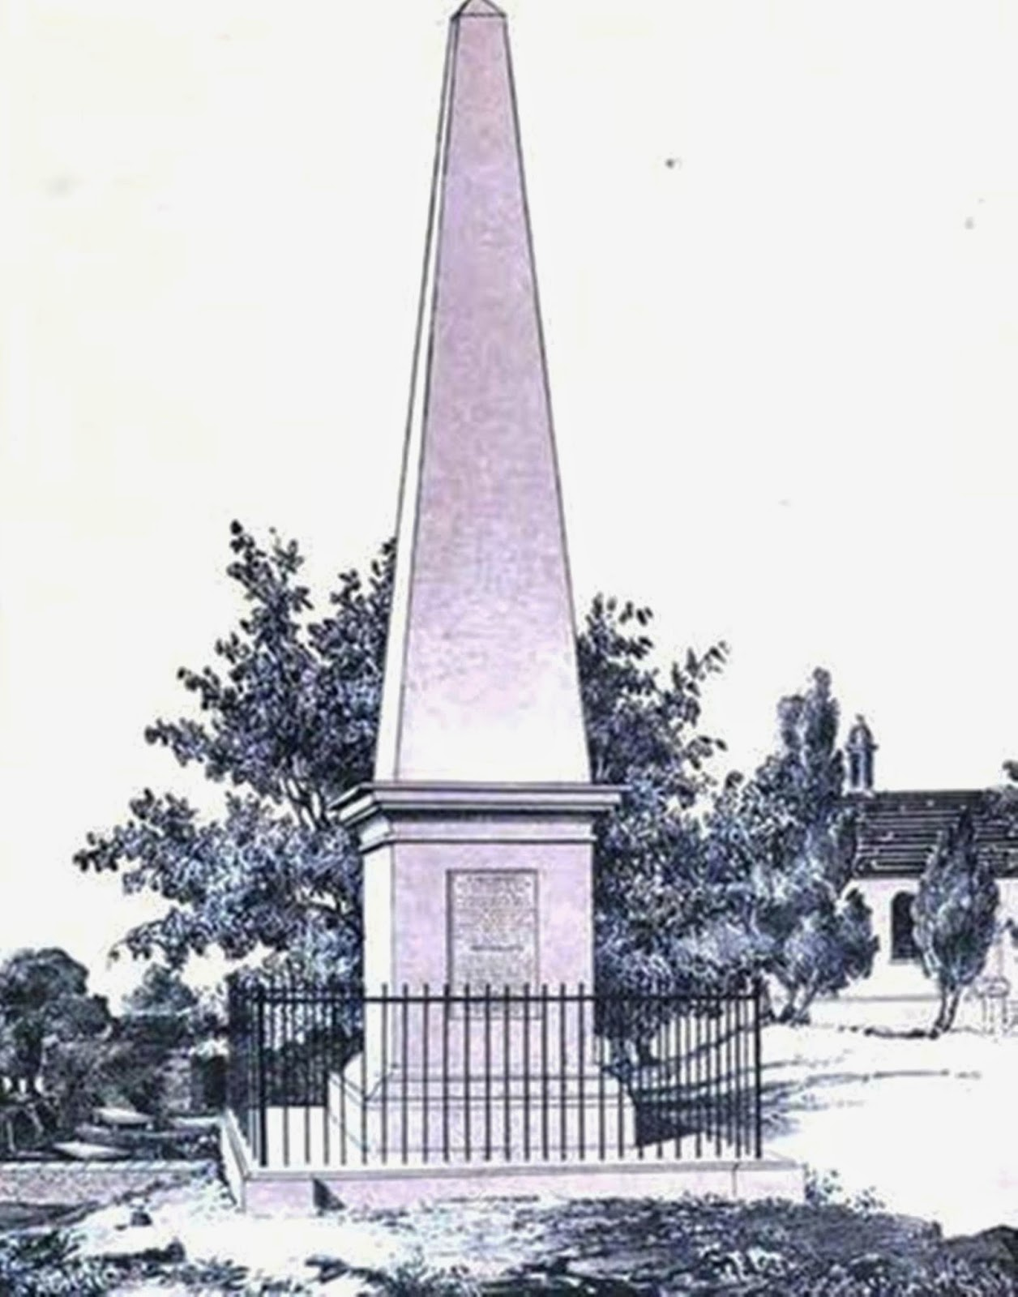
Many a fried of his kith and kin,
Were affected by the sad news
Of the one who fell in France,
Fighting against Bonaparte yonder;
Though Wellington was present,
He scattered the camp from the earth,
Our loss is all too evident,
That has not left in our time many Gaels.

News freshly arrived,
Depressed the Lochaber folk,
They are mirthless, without cheer,
Without joy or in any mood for music;
They’ve lost a friend at court:
A brave man who supported his people,
Many a Lord and Duke,
Are grieved by such a great loss.

A ship has been seen in the narrows,
Sailing with the wind from the west,
Going to take shelter in the trees,
To me the news is poignant:
A beautiful heroic corpse,
On board dearly paid for the voyage,
Leaving women on both sides of Lochiel
Weeping and wailing in grief.

At the Battle of Waterloo,
The renowned hero famed in every land fell,
A great, noble Cameron,
Who won the honour of the King’s court;
O man who wouldn’t turn his back
When matters came to a head,
Many a time you proved your worth,
As we got truthful reports of your exploits.

Your blood poured out with fury,
That has left all your kin so sad,
Your wounds wept so much,
That no physician could heal you,
With only your servant present
It has been a sad time ever since;
The fatal wound by which you fell in battle
Came not from the shoulder but the front.
You were the flock’s shepherd,
Protecting them from harm’s way without loss,
Until you lead them [into battle],
They were all trained in your camp;
Able, hardy and brave,
As long as you commanded them,
Your enemies would be smited and badly wounded,
And running for their lives in ratreat.

The great day the war ended,
In every land over by,
Many a hero paid the price,
That fell fighting in France;
Clan Cameron paid a high cost
As they will not return without loss,
And although peace has now come
Both ransom and revenged were dearly bought.

The day they received from France
Your precious from over the sea,
In a pine-boarded coffln,
Though that welcome was sad and cold;
Your honour was greatly raised,
More valuable than gold from a mill,
It be taken home safely, as by right,
To be interred in your native soil.

A perfect, great warrior,
Who has not heard your name,
Whether from here or there,
That brought you honour with proof;
In your figure and bearing,
When in the fray of battle,
A fierce, bloodthirsty lion,
A great, skilful, hero during conflict.

A man who exuded confidence,
Not found even among five thousand,
With no fault to speak of,
From the top of your head to your feet;
Armed handsomely by your side,
With which you’d go to into the heat of battle,
Whether in war or peace,
You’d win victory over all comers.

Your ruddied and shapely visage
Mounted upon an agile, stately-headed stallion,
At the very forefront of your people,
When you would draw together the brigade;
With an unsheathed sword,
By your hand victory would be won,
With a thin, hard, sharp blade
Skulls split and ears would fall to the field.

Pity those who would try and pluck a bristle
From your nostrils when flared in anger,
Deft right hand in arms,
When the moment would seize you,
To preserve the king’s honour,
You would not neglect your duty,
Grievous to your kin is your loss,
That you no longer remain to tell the tale.

That was truly sad, heart-wrenching news
That left Sir Ewen bereft and stunned,
Little wonder he is grief struck,
With tears running down his cheeks,
Oh perfect, true son and heir,
Who won fame throughout his career,
That has died by a grievous wound,
Tonight is interred in the earth.

In Kilmallie of the virtues,
The great and powerful hero is enclosed,
In the proper native soil,
Under a tower of neatly, sculpted stone;
And whatever epitaph,
May be inscribed on a broad slab,
It’s obvious that you were a captain,
Who won honour by the King’s right.

So long as the sun travels
Westwards to the heavens on high,
Not until the relentless heat,
Melts the mountains down,
Your exploits will be renowned,
Not until every hill and shore wears away,
Your deeds will stand full witness
And your memory will for ever last.

In Lodon of the cloask,
Were they greatly amazed by events,
By which they spent gold,
By your deft and skillful hand,
And if any kind of handiwork,
Could bring you back from the dead,
Then George’s crown would not allow
You to lie so untimely under the sod.
Illustrations:
Col. John Cameron of Fassiefern (1771–1815) by W. P. Rodgers painted in 1876.
Fassiefern House, Lochielside.
Memorial Obelisk to Col. John Cameron of Fassiefern.

References:
Rev. Archibald Clerk., Memoir of Colonel John Cameron, Fassiefern, K.T.S. (Glasgow: Thomas Murray & Son, 1858)
Ailean Dughalach, Orain, Marbhrannan, agus Duanagan Ghaidhealach (Inverness: Alastair Mac-an-Toisich, 1829)
Calum I. Maclean, The Highlands (London: B. T. Batsford, 1959)
SSS NB 6, pp. 540–42

