Kinrara, Waterloo Cairn
© Copyright and database right 2014. All rights reserved. Ordnance Survey Licence number 100020548.
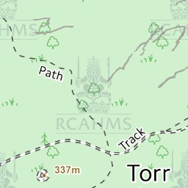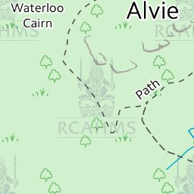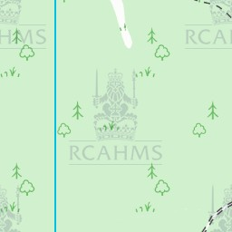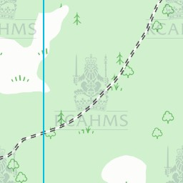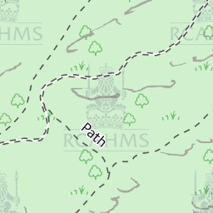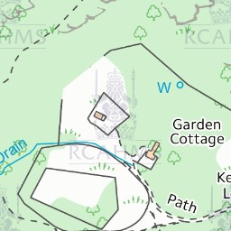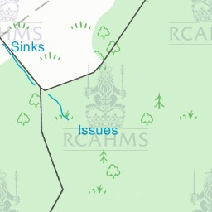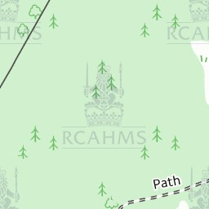


Collection Items

Search Room
1 Manuscripts

Public Contributions
1Text (Add More)
4Photos (Add More)
Return to Site Details
Alternative Names Torr Alvie
Site Type COMMEMORATIVE CAIRN
Canmore ID 14884
Site Number NH80NE 19
NGR NH 87255 08630
Council HIGHLAND
Parish ALVIE
Former Region HIGHLAND
Former District BADENOCH AND STRATHSPEY
Former County INVERNESS-SHIRE
Datum OSGB36 - NGR
Canmore Mapping
View this site on a map

Public Photo Contributions
Bovenkant formulier
Comment on this photo or add your own image to this site -
Onderkant formulier
Public uploaded images in Canmore.
Click on an image to view it within Canmore.
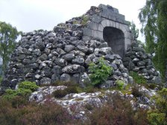
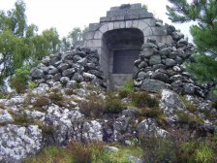
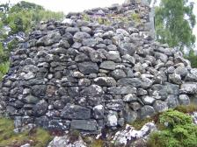
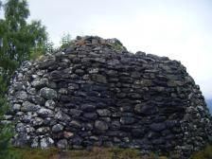

- 1

Waterloo Cairn
© Heather Stedman 29 September 2014
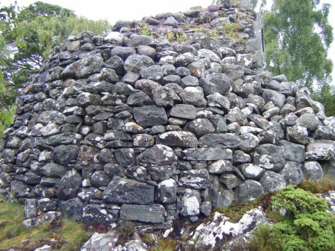
© All Rights Reserved

