BOWOOD HOUSE (CALNE)
Collections and Exhibits

Orangery

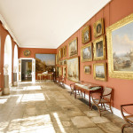
The house is entered from the Upper Terrace, through the central door to the Adam Orangery. Originally designed as a large conservatory, the Orangery is now primarily a picture gallery, containing the remaining parts of the two great Lansdowne Collections of paintings and sculpture.Here are family portraits, some of which belonged to the 1st Marquess, and a number of important Old Masters and contemporary 19th-century paintings purchased by the 3rd Marquess. The large Clarkson Stanfield canvasses were in the dining room of the Big House – the only room preserved when the Big House was demolished in 1955 and now the Committee Room at Lloyd’s of London. The small display of paintings relating to Napoleon came into the family with Emily Flahault, 4th Marchioness of Lansdowne, whose father, the Comte de Flahault, was Napoleon’s aide-de-camp.

Chapel
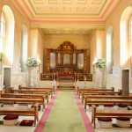
Opposite the Orangery entrance are the great doors to the Chapel. Created in the early 19th century for the 3rd Marquess by C.R.Cockerell, the Chapel is still used for special services and concerts. The chamber organ was installed in 2004, to commemorate the millennium; the pipes are set into an earlier case of 18th-century or, possibly, 19th-century date. The marble torchères came from the dining room of the Big House and the railings from the staircase of the Big House. The fine French Boulle bracket clock reflects the family’s French connections. The stained glass partly dates to the 3rd Marquess’ time, but of the seven glass copies of the Raphael tapestry cartoons now in the Victoria & Albert Museum, only one remains, over the door into the Orangery.

Laboratory
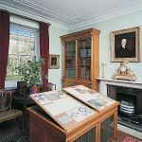
Through the doors at the east end of the Orangery is a small ante-room to the library, known as the Laboratory. Here, scientist Dr Joseph Priestley, tutor to the 1st Marquess’ two sons, discovered oxygen in 1774. In those days the room was full of scientific equipment – all sold when the 1st Marquess died.

Library
Beyond the Laboratory is the Library. The decorative scheme dates back to the early 19th century, when the 3rd Marquess employed C.R.Cockerell to
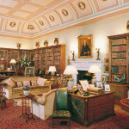
replace the original Adam interior. The Wedgwood ‘Etruscan’ style vases were commissioned specially for the room. The marble chimneypiece was designed by Adam and came from the drawing room of the Big House. The portrait above is of the 2nd Marquess. It was in this room that the great Bowood house parties would meet after dinner to read, play chess, sing, and talk about politics and other topics of the day. Talleyrand, Jeremy Bentham, Lord Macaulay and Irish poet Tom Moore were among the many visitors who enjoyed the stimulating Lansdowne hospitality.

Sculpture Gallery
Through a small entrance hall at the other end of the Orangery is the Sculpture Gallery, created by the present Marquis of Lansdowne in 1980. Designed by Adam as a menagerie or zoo for wild animals
,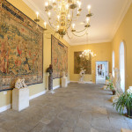
with false windows on the south side, it later became part of the stables. We know that a leopard and an orang-utan were kept here in the 18th century. Nowadays, the gallery houses pieces from the Lansdowne sculpture collections. On the north wall hang two large and very fine 16th-century Flemish tapestries. Among the classical marbles is a Roman copy of Myron’s Discobolos (discus thrower), which was wrongly restored in the 18th century as a figure carrying a cult statue. Dorothea, a 19th-century sculpture by John Bell, was purchased by the 3rd Marquess; the figure was then so popular that it was reproduced in a smaller version in Parian china for the mass market.

Exhibition Rooms
A staircase at the west end of this gallery leads to the exhibition rooms and a fascinating array of family treasures. Examples of 18th-century costume of the time of the 1st
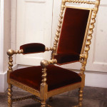
Marquess are seen in the Georgian Room, while the early 19th-century Albanian costume, in which Lord Byron was painted by Thomas Phillips in 1813, is displayed in its own showcase. The Victorian Room houses, among other memorabilia of the period, Queen Victoria’s wedding chair and a sprig of waxed orange blossom, both given by her to the 3rd Marquess after her wedding in 1840.
The 5th Marquess’s collection of Indiana is particularly interesting. Here, in the Indian Rooms, are some of the exotic gifts he purchased or was given as Viceroy (1888–94). Near the Indian displays is a collection of family porcelain, including German and French 19th-century Dresden and Sèvres, English Staffordshire and Wedgwood, and a particularly fine late 17th-century garniture of Japanese Arita ware vases.Examples from Bowood’s outstanding collection of British watercolours are hung on the walls of the Exhibition Staircases and Corridor; while the most important group of watercolours and drawings, by R.P.Bonington, is displayed in the Top Exhibition Room. Among other painters represented are Lear, Roberts and Turner.
Also on show in the Top Exhibition Room are the Keith Jewellery Collection, family miniatures, and the Napoleonic Collection. The fabulous Keith jewels belonged to Admiral Lord Keith, grandfather of the 4th Marchioness;
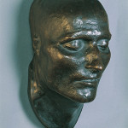
they principally comprise jewel-encrusted orders and ceremonial objects presented to the Admiral for his successes against the French in the Mediterranean. The Napoleonic Collection also came into the family via the 4th Marchioness; it was largely formed by her father, the Comte de Flahualt, who was Napoleon’s aide-de-camp. Here are Napoleon’s death mask, pieces of gilded Imperial Sèvres porcelain and other unusual treasures, such as Napoleon’s handkerchief! (cursief van rkv!)

Research
Bowood House has an extensive archive that can be used for research purposes on all aspects of Bowood House and its history. If you would like to use this facility, please print and complete the following Research Request Form and send it by post with the enclosed appropriate payment. Unfortunately, requests via e-mail cannot be accepted.
For more information click here.

